shortest path trees from source location Charlotte to 5 cities Jacksonville, Tallahassee, Orlando, Tampa, Miami:

**Shortest path is printed in reverse order as below**

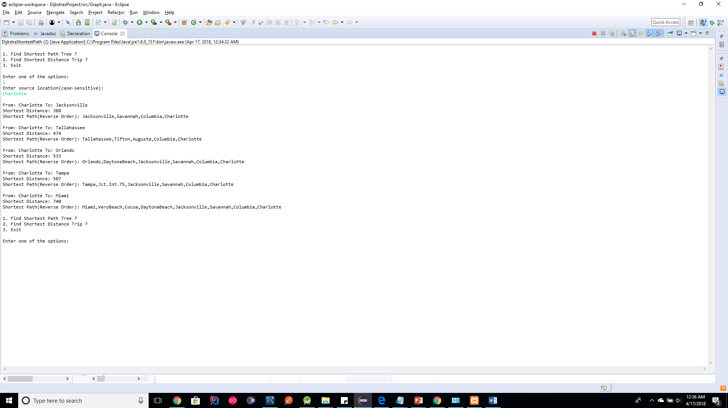

Shortest distance trip from charlotte to 5 cities in Florida and then back to Charlotte

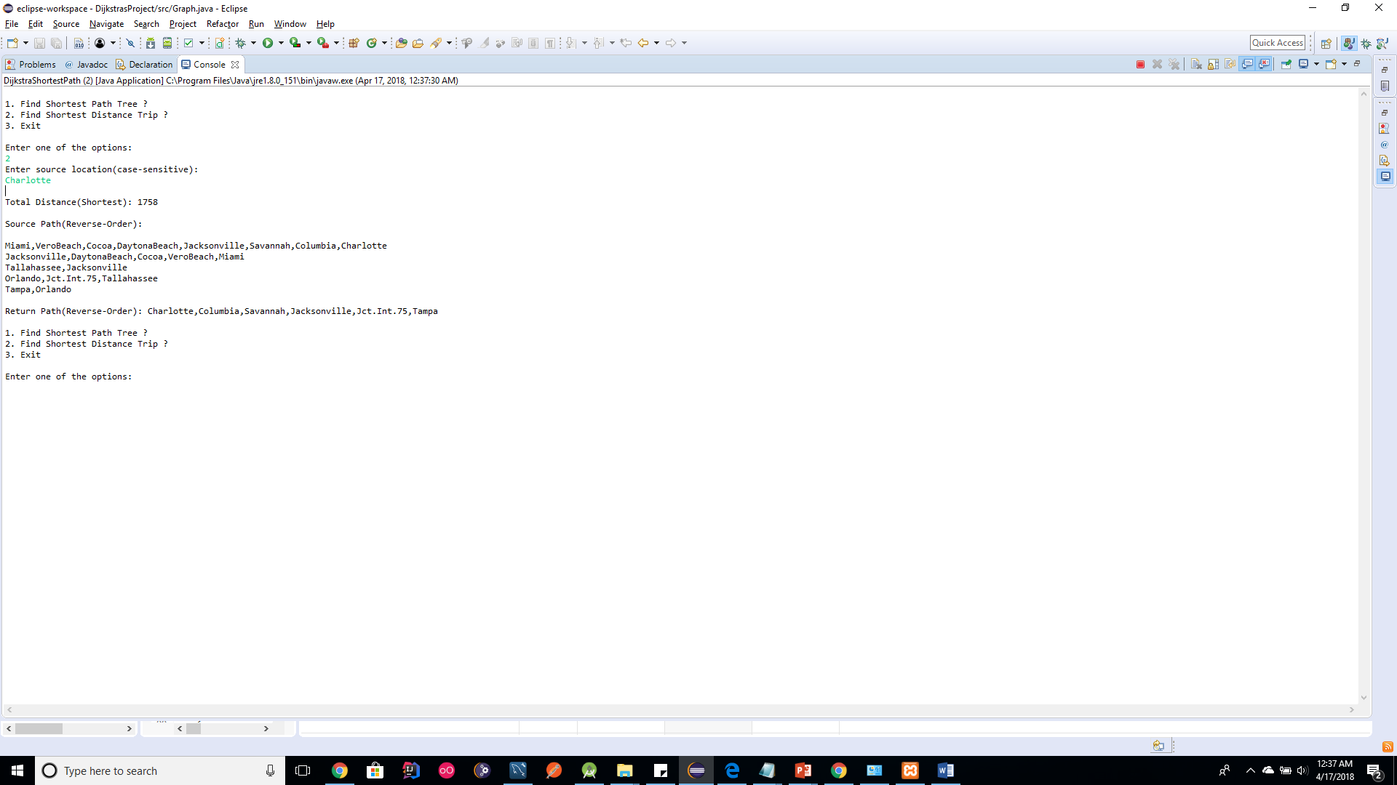

**Total Distance(Shortest):** 1758 - This is the total distance starting from charlotte and travel to 5 major cities and then return to the charlotte.

**Source Path(Reverse-Order):**

There are 5 cities to travel. so we can see 5 lines.

When I say reverse-order, this is the format of each line below: [First Destination out of 5 cities], [ Path taken to reach First Destination], [Starting City]

so, in the first line below,

Miami is the first destination out of 5 cities

Path taken from Charlotte to Miami is Columbia, Savannah, Jacksonville,DaytonaBeach, VeroBeach, Miami

Starting City is Charlotte for the first line....

Similar interpretation for rest of the lines.....

Miami, VeroBeach, Cocoa,DaytonaBeach,Jacksonville,Savannah,Columbia,Charlotte   -

Jacksonville, DaytonaBeach,Cocoa,VeroBeach,Miami

Tallahassee,Jacksonville

Orlando,Jct.Int.75,Tallahassee

Tampa,Orlando

**Return Path(Reverse-Order):** Charlotte,Columbia,Savannah,Jacksonville,Jct.Int.75,Tampa  - Last destination out of 5 cities was Tampa as you can see the 5th line. So this the return path from Tampa to Charlotte.....when we read it in reverse order.....